YOUR GUIDE TO
Beech Tree Farm


Welcome to Beech Tree Farm. Scan our QR code below if you would like to view this electronically.

If you have any questions about this guide, please ask Jodie the home manager, Gemma + Ari, her deputy home manager’s and her friendly staff team who are looking forward to supporting you.
Where to find information in this guide.
The home and staff team 3-5
Places in the area 3
Washing clothes 4
The staff team 4-5
Your keyworkers 6
This is home 6-7
Having your say 6
Your bedroom 6
Clothing 7
Pocket money 7
Incentives 7
Education 7
Keeping in contact 7-8
Staying healthy 8
Expectations 8-9
Health and Safety 9
Extra support and help 9
Making a complaint 9
Advocacy 9
Talk to staff 9
Responsible individual – Hayley 10
Visitors to the home 10
Important telephone numbers 10-11

The Home and Staff Team

  - Beech Tree Farm is a 2- bedroom home with 3 independent living flats, located in Swansea in south Wales. It is on a private lane and has a big garden, with lots of room for you to play sports or enjoy some garden games. We love having plenty of BBQ ‘s and picnics in the summer.

The young people who stay at Beech Tree Farm can be aged between 13-18 years.

  - 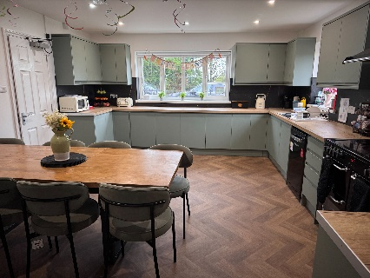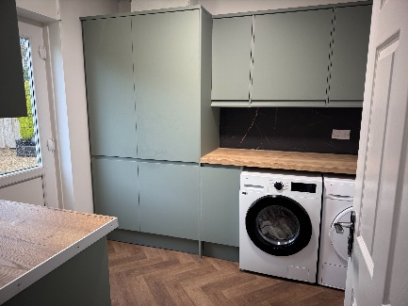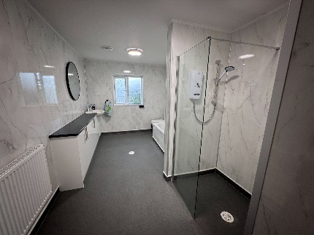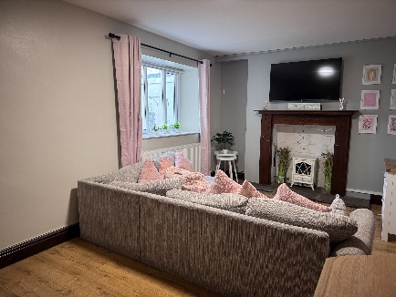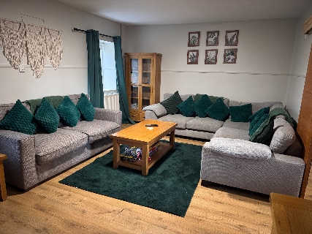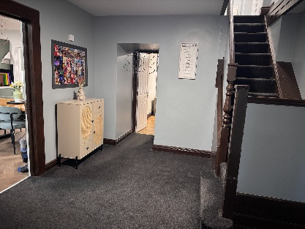

Places in the area:

You can get to Swansea with the support from staff and the homes vehicle.
Mumbles and the Gower peninsular are a short drive away as well as lots of beaches along the coast. We are also not too far away from the Brecon Beacons and Cardiff. We also have access to local bus and train routes.
As we are not far from the mountains, there are some lovely walks and sights to see. But if you prefer to spend some time indoors we have lots of fun game and activities.

Washing Clothes:
Laundry: there are facilities at Beech Tree Farm for you to do your laundry staff can support you to do this, you will have your own laundry basket. 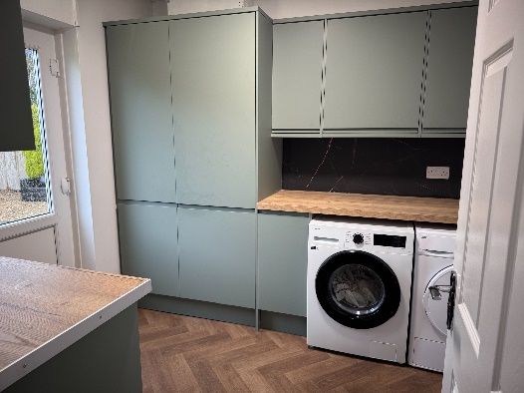

The staff team:
Before you move in, the staff will meet with you and your family or carer’s so you can get to know us.

← This is Jodie, who is the home manager.



This is Ari, one of our deputy home managers.

This is Gemma, one of our deputy home managers. →


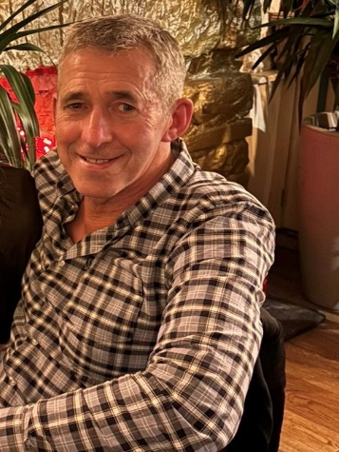
This is Anmarie, one of our seniors at Beech Tree Farm →
This is Tony, another one of our seniors at Beech Tree Farm.


This is Kimberley, another one of our seniors at Beech Tree Farm
This is Ellie, another one of our seniors at Beech Tree Farm.

You will also have a keyworker (or sometimes 2!) who will work with you closely and report back your needs, the whole team will help you to settle in and feel safe, remember there are no silly questions!
  - We can help you in areas that you need like:
- Daily living skills
- Life skills
- Money handling
- Hobbies and interests
- Leisure activities
- Religion
- Life goals and aims
There are support staff available at Beech Tree Farm 24 hours a day.

Your keyworkers:
- Support you at your meetings.
- Monitor your health appointments - Your keyworkers will sign you up to a doctors and dentist in the area and any other services you need.
- Review your plans with you and check all your wishes and goals are included.
- Write reports about how you are getting along.
- Help you to stay in contact with people who are important to you.
- Help you plan activities and complete a weekly planner which included daily living skills but also fun activities that you enjoy too!
- Remember the whole team are here to support you with whatever you need.

This Home

Having your say:
We want you to be comfortable, happy and involved in the running of home. So, we have:
- Monthly house meetings
- Monthly surveys, please let us know how
- We can improve
- Reviews
- Meetings with the manager
- You can go to these in person or attend via Skype, email, telephone

Your bedroom:
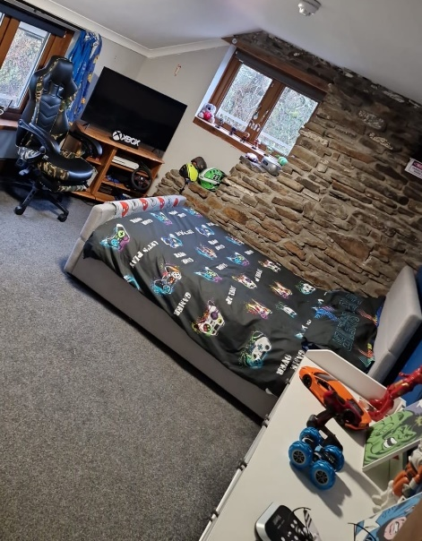
  - Your bedroom is where you can keep all your belongings.
  - You may want to have your favourite colour on the walls or on your bedding, or put up your favourite photos, pictures. We can help with these when you feel ready. Your bedroom is your space where you can go to have some space or to go to play quietly if you want to and we will check from time to time to check you’re okay.
  - When you go to bed, staff can spend some time with you, reading, watching TV until you feel tired, if you want us to.
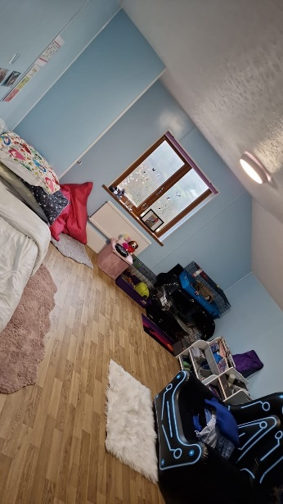
  - Before staff leave your room, they will turn your TV off for you to have a good sleep.
  - We will have to look in your room every day to check that it is not too untidy and that your furniture is not broken. If your room needs a tidy up, we can help you or if you can do this yourself , but please remember, ask if you need something or tell us if something is broken.

Clothing:
  - We will go in your bedroom to check to see if you need any new clothes, like new coat, socks, jumpers, trainers, shoes, or anything which you may need.

Pocket money:
  - You will have pocket money on a Friday, after school time. For you to have your pocket money we like to see if your bedroom is tidy. We will have a plan to say if you can have your pocket money in your hand, if not, staff will go with you to spend the money and put any money not spent in the office to save for you.
  - You can get £….. pocket money each week!

Incentives:
  - When you move in we will put together an incentive programme with you so that you have rewards and can celebrate by doing things you enjoy when you are doing well. You can earn up to £7 on your weekly incentives.

Education

  - Your Social Worker will let us know where you go to school and if we will be taking you to and from your school.
  - BUT if you are not able to stay in your previous school, there are some things we will do while we are waiting to go to school. We help you keep busy in the day, like cooking cakes/biscuits, going for walks, doing some basic education at the house which may include playing games, colouring, arts and crafts.
  - Your Social Worker may arrange for a Home Tutor to come to see you at Beech Tree Farm not for you to miss out.
  - We have teachers who work for Priority Childcare, and they work at the other’s houses. Your Social Worker may agree for you to attend there. We will take you to and from the other home.
  - Staff will stay with you if it is in your plan, which we can talk to your Social Worker about.

Keeping in contact
  - There will be a plan in place for your contact with your family or other important people in your life.
  - Your Social Worker will let us know when you come to stay with us who they are. A meeting will take place with your Social Worker, and this is usually after you move into Beech Tree Farm.
  - When you have someone coming to see you, they will be able to see you in the living room, or if the weather is good, we have a great back garden you can spend time in.
  - We want you to be happy and make friends when you stay with us. We would like to know your friend’s names, where they live and get to meet them. We will put a plan in place to help you meet them and be able to go on activities in the community if it is a safe place to go. We might also come with you to make sure you are okay.
  - Your social worker will visit you regularly and we will keep in touch with them to let the know how you are doing. If you wanted to speak to your Social Worker, please tell us and we can phone them for you.

Staying healthy:
  - When you arrive, we will register you with a local doctor, dentist and optician, if you were not able to stay with the one you were with before moving here. We will take you to regular appointments to make sure your teeth and eyes are okay.
  - If you are ever feeling unwell though, please tell one of the staff and they will take care of you. They will phone the Doctor and make an appointment for you to see them. Your Social Worker will also give us permission to be able to go the chemist to have some over the counter medication, if needed, to help us to look after you.
  - We will support you to be fit and healthy and you will always find healthy snacks available at Beech Tree Farm. We will encourage you to make healthy meal choices but understand that not everyone likes everything so you will be involved in choosing the meals and what is bought in the house shop.

Expectations

  - We have some rules at Beech Tree Farm, which are for everyone to be able to live in a home which is comfortable and safe.
- Beech Tree Farm has a no smoking policy
- Staff will check your bedroom daily to make sure it is clean & tidy
- Should staff have any concerns for the safety of yourself or others they can access your bedroom without consulting you
- We have a zero-tolerance policy on drugs and alcohol
- Any screen time is pre agreed
- Internet & mobile phones – have under 18 privileges, we will discuss this with you and your social worker
- We ask for you to be polite to everyone, visitors too, no matter how you feel, though we know this can be difficult at times.
- We will ask you to help us to do some jobs around the house to keep your home clean and tidy. Some jobs might be helping to put your dirty dishes in the kitchen after using them or putting sweet, crisp paper in the bin, helping to keep all the house and the garden tidy.
- We ask for you not to break anything, but if you do see anything damaged around the home please let staff know.
- We ask for you to go to your bed on time, which will be agreed when you move in. Your Social Worker will also have a say about what time this will be.
- We will call you in the mornings to make sure you are ready for any appointments that you may have and to check that you are okay.

Health and Safety:
  - The staff will do health and safety checks every week this may include setting off the fire alarms and doing evacuations, if there is a fire then everyone must go and stand together in the car parking area, the staff will show you what to do on your first day at Beech Tree Farm and you can always take part doing the weekly checks if you want to!
  - If you ever see something which worries, you tell a member of staff.

Extra support and help

Active offer:
At Beech Tree Farm we offer the choice for our young children to engage in the Welsh language. We provide a service in Welsh without someone having to ask for it. If a young child would like to communicate in Welsh, we can provide this this for them. By making an ‘Active Offer’ means that we are not making assumptions that all Welsh speakers speak English. It ensures Welsh-speaking children are treated with dignity and respect by asking them what their preferred language is and acting on it. Here at Beech Tree Farm we have a Welsh speaking staff member who is happy to engage with the children in Welsh.

Making a complaint:
If there is anything you’re concerned about have a look at the complaints booklet handed to you with this guide.

Advocacy:
  - if you need any help or support with big issues that we can’t help you with then the home can contact advocacy services to meet with you and speak on your behalf for serious or legal issues.

Talk to staff:
  - If you are not happy about the way you are being looked after, you may want to talk about how you are feeling, and staff will be here to listen and will write down what is making you unhappy, or you can write it down.

Responsible individual – Hayley:

  - There is a responsible individual for Beech Tree Farm her name is Hayley Phillips, and she will visit the home regularly as she makes sure the home is run well and everyone is safe and happy. There is a poster on the wall with Hayley and all the people you may need to contact in Priority Childcare if you wish to raise a concern.
  - ‘Hi and Welcome to Beech Tree Farm, I am Hayley Phillips, I look forward to chatting to you when I visit, please let me know if you are unhappy with anything and I will try my best to help you. I will ask you to show me your bedroom, I like to check you have everything you need. Your key worker will meet with you when you first move in, they will show you important things such as how to make a complaint, the staff have my details if you would like to contact me or if you prefer to speak to somebody else you can contact Head office on 02920029922.”
  - You can also phone your Social Worker or Advocacy Service, Worker. We can help you to phone them if you wish.
  - Social Worker: -…………….…………….. Telephone number: -…………….……………..
  - Advocacy SERVICE: - ……………………Telephone number: -…………….……………..

Visitors at the home

While residing at Beech Tree Farm, you will have a few visitors visiting your home such as:
- Staff and other young children from another service
- Social workers
- Maintenance
- Katy Morris – area manager
- Johan Perry – quality support manager
- Other managers from other services
This is Katy Morris, area manager.

Important telephone numbers

  - Child line: 0800 1111
  - NSPCC 08000560566
  - Kidscape (advice and info on bullying) 02077303300
  - National Youth Advocacy Service 0800616101
  - Victim Support 08453030900
  - National Drugs Helpline 0800776600
  - Lesbian and Gay Switchboard 02078377324
  - Sexual Health Wales 08456048484
  - Commission for Racial Equality 02920729200
  - Children's Commissioner for Wales
  - Oystermouth House
  - Charter Court
  - Phoenix Way
  - Llansamlet,
  - Swansea
  - SA7 9FS
  - Telephone:-01792765600 Email: post@childcomwales.org.uk

Children’s Commissioner for Wales
Llewellyn House
Harbourside Business Park
Harbourside Road
Port Talbot
SA13 1SB
Telephone: 01792 765600 Email: post@childcomwales.org.uk

  - CIW
  - Welsh Government Office
  - Rhydycar Business Park
  - Merthry Tydfil
  - CF48 1UZ
  - Tel: 0300 7900 126
  - Email: ciw@gov.wales
  - Merthyr Tydfil County Borough Council
  - Civic Centre
  - Castle Street
  - Merthyr Tydfil
  - CF47 8AN
Shropshire Children Looked After Team
Shropshire Council
Shirehall,
Shrewsbury,
SY2 6ND
Tel: 01743 250020

  - Telephone: 01685 725000 If there are any other numbers you need, ask one of the staff and we can write them in here.

