I888888888/]#’
Hi, ……………
Welcome to Forestry House

If you have any questions about this guide, please ask Simon the Home Manager and his friendly staff team who are looking forward to supporting you.


A CHILDRENS GUIDE TO FORESTRY HOUSE
Where to find information in this Guide.

The home & staff team 2

Places in the area – 2

washing clothes – 2

THE STAFF TEAM – 2

Your keyworkers: 3

THIS IS HOME 3

Having your say 3

Your bedroom - 4

Clothing - 4

POCKET MONEY - 4

Incentives - 5

EDUCATION 5

Keeping in contact 6

STAYING HEALTHY - 7

expectations 7

Health & safety – 9

Extra support & help 9

Making a complaint – If there is anything you are concerned about a guide about complaints with this booklet. 9

Advocacy - 9

Talk to staff - 9

Responsible individual hayley - 9

visitors to the home 10

SOME IMPORTANT TELEPHONE NUMBERS 10

The home & staff team

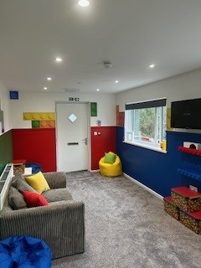
Forestry House is a 5-bedroom home, with a sperate independent flatlet within the grounds, located in the mountains of small village called Cwmgrach in south Wales. It is at the top of a private lane and has a big garden, with lots of room for you play sports or enjoy some garden games. We love having plenty of BBQ ‘s and picnics in the summer.

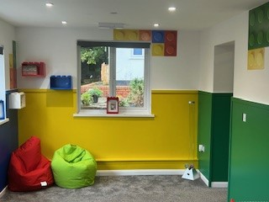

The young people who stay at Forestry House can be aged between 8 – 19.

Places in the area –
You can get to Swansea with the support from staff and the homes vehicle.

Mumbles and the Gower peninsular are a 30–40-minute drive away as well as lots of beaches along the coast. We are also on the doorstep of the stunning Brecon Beacons and a 40-minute drive to our capital city of Cardiff. We also have access to local bus and train routes.
As we are in the mountains, there are some lovely walks and sights to see. But if you prefer to spend some time indoors, we have a games room with lots of fun activities.
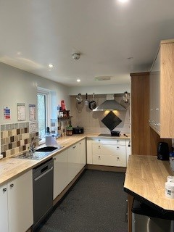
washing clothes –
Laundry: there are facilities at Forestry House for you to do your laundry staff can support you to do this, you will have your own laundry basket.



THE STAFF TEAM –
Before you move in the staff will meet with you and your family or carer’s so you can get to know us.
There is Simon Parr who is the home manager, and two senior support workers Bethan Phillips and David Richards and a team of support workers. You will also have a keyworker (or sometimes 2!) who will work with you closely and report back your needs, the whole team will help you to settle in and feel safe, remember there are no silly questions!




We can help you in areas that you need like:
Daily living skills
Life skills
Money handling
Hobbies and interests
Leisure activities
Religion
Life goals and aims.
There are support staff available at Forestry House 24 hours a day.

Your keyworkers:
- Support you at your meetings.
- Monitor your health appointments - Your key workers will sign you up to a doctor and dentist in the area and any other services you need.
- Review your plans with you and check all your wishes and goals are included.
- Write reports about how you are getting along.
- Help you to stay in contact with people who are important to you.
- Help you plan activities and complete a weekly planner which includes daily living skills but also fun activities that you enjoy too!
- Remember the whole team are here to support you with whatever you need.

THIS IS HOME

Having your say
We want you to be comfortable, happy, and involved in the running of home.

So, we have -

- Monthly house meetings
- Monthly surveys, please let us know how we can improve.
- Reviews
- Meetings with the manager
- You can go to these in person or attend via Skype, email, telephone.

Your bedroom -

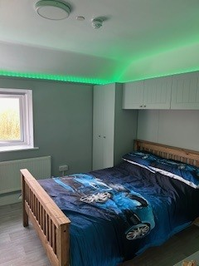
Your bedroom is where you can keep all your belongings. You may want to have your favourite colour on the walls or on your bedding, or put up your favourite photos, pictures. We can help with these when you feel ready. Your bedroom is your space where you can go to have some space or to go to play quietly if you want to and we will check from time to time to check you’re okay.
When you go to bed, staff can spend some time with you, reading, watching TV until you feel tired, if you want us to.
Before staff leave your room, they will turn your TV off for you to have a good sleep.
We will have to look in your room every day to check that it is not too untidy and that your furniture is not broken. If your room needs a tidy up, we can help you or if you can do this yourself, but please remember, ask if you need something or tell us if something is broken.
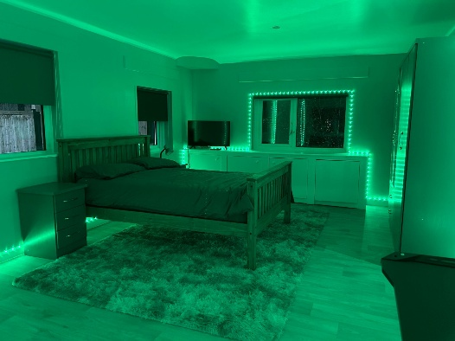

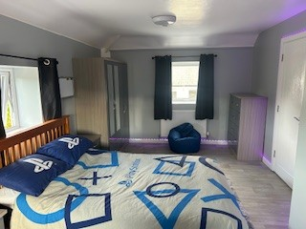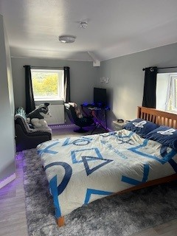


Clothing -
We will go in your bedroom to check to see if you need any new clothes, like new coat, socks, jumpers, trainers, shoes, or anything which you may need.

POCKET MONEY -

You will have pocket money on a Friday, after school time. For you to have your pocket money we like to see if your bedroom is tidy. We will have a plan to say if you can have your pocket money in your hand, if not, staff will go with you to spend the money and put any money not spent in the office to save for you.
Your key worker will let you know how much pocket money you will receive each week.

Incentives -
When you move in we will put together an incentive programme with you so that you have rewards and can celebrate by doing things you enjoy when you are doing well. You can earn.

Your key worker will let you know how much money you will receive each week.



EDUCATION

Your Social Worker will let us know where you go to school and if we will be taking you to and from your school.
BUT if you are not able to stay in your previous school, there are some things we will do while we are waiting to go to school. We help you keep busy in the day, like cooking cakes/biscuits, going for walks, doing some basic education at the house which may include playing games, colouring, arts and crafts.
Your Social Worker may arrange for a Home Tutor to come to see you at Forestry House not for you to miss out.
We have teachers who work for Priority Childcare at Ty Trafle, and they also work at the other’s houses. Your Social Worker may agree for you to attend there. We will take you to and from Ty Trafle or the other homes.

Staff will stay with you if it is in your plan, which we can talk to your Social Worker about.

Keeping in contact

There will be a plan in place for your contact with your family or other important people in your life.
Your Social Worker will let us know when you come to stay with us who they are. A meeting will take place with your Social Worker, and this is usually after you move into Forestry House.
When you have someone coming to see you, they will be able to see you in the living room, or if the weather is good, we have a great back garden you can spend time in.


We want you to be happy and make friends when you stay with us. We would like to know your friend’s names, where they live and get to meet them. We will put a plan in place to help you meet them and be able to go on activities in the community if it is a safe place to go. We might also come with you to make sure you are okay.


Your social worker will visit you regularly and we will keep in touch with them to let the know how you are doing. If you wanted to speak to your Social Worker, please tell us and we can phone them for you.
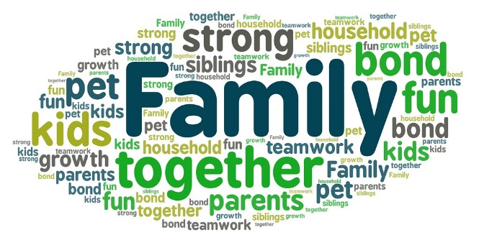

STAYING HEALTHY -

When you arrive, we will register you with a local doctor, dentist, and optician, if you were not able to stay with the one you were with before moving here. We will take you to regular appointments to make sure your teeth and eyes are okay.

If you are ever feeling unwell though, please tell one of the staff and they will take care of you. They will phone the Doctor and make an appointment for you to see them. Your Social Worker will also give us permission to be able to go the chemist to have some over the counter medication, if needed, to help us to look after you.
We will support you to be fit and healthy and you will always find healthy snacks available at Forestry House. We will encourage you to make healthy meal choices but understand that not everyone likes everything so you will be involved in choosing the meals and what is bought in the house shop.

VALUES

We have some values at Forestry House, which are for everyone to be able to live in a home which is comfortable and safe.

- Forestry House has a no smoking policy, this includes ‘vapes’, if you do have to smoke then the designated smoking area is outside the front gate.
- Staff will check your bedroom daily to make sure it is clean & tidy.
- Should staff have any concerns for the safety of yourself or others they can access your bedroom without consulting you.
- We have a zero-tolerance policy on drugs and alcohol.
- Any screen time is pre agreed.
- Internet & mobile phones – have under 18 privileges, we will discuss this with you and your social worker.

- We ask for you to be polite to everyone, visitors too, no matter how you feel, though we know this can be difficult at times.
- We will ask you to help us to do some jobs around the house to keep your home clean and tidy. Some jobs might be helping to put your dirty dishes in the kitchen after using them or putting sweet, crisp paper in the bin, helping to keep all the house and the garden tidy.
- We ask for you not to break anything, but if you do see anything damaged around the home please let staff know.
- We ask for you to go to your bed on time, which will be agreed when you move in. Your Social Worker will also have a say about what time this will be.
- We will call you in the mornings to make sure you are ready for any appointments that you may have and to check that you are okay.

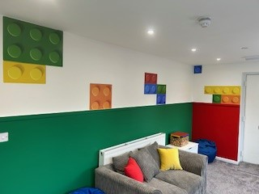


Health & safety – 

The staff will do health and safety checks every week this may include setting off the fire alarms and doing evacuations, if there is a fire then everyone must go and stand together in the car parking area, the staff will show you what to do on your first day at Forestry House and you can always take part doing the weekly checks if you want to!
If you ever see something which worries, you tell a member of staff.

Extra support & help

Making a complaint – If there is anything you are concerned ABOUT A guide about COMPLAINTS WITH this booklet.
Advocacy - if you need any help or support with big issues that we can’t help you with then the home can contact advocacy services to meet with you and speak on your behalf for serious or legal issues.
Talk to staff - If you are not happy about the way you are being looked
after, you may want to talk about how you are feeling, and staff will be
here to listen and will write down what is making you unhappy, or you
can write it down.

If you would like anything explained to you in Welsh then we have a staff
members that will be able to help you.



Helo, Emma ac Tom ydyn ni. Ni yw'r rhai sy’n siarad Cymraeg yn Nhŷ Coedwig.
Os mae'n well gen ti siarad Cymraeg, neu os wyt ti eisiau i rywbeth gael ei gyfieithu, jest gofyn!

Hello, we are Emma and Tom. We are the Welsh speakers of Forestry House.
If you prefer to speak in Welsh or would like anything translated, please just ask.

Responsible individual

There is a responsible individual for Forestry House her name is Hayley Phillips, and she will visit the home regularly as she makes sure the home is run well, and everyone is safe and happy. There is a poster on the wall with Hayley and all the people you may need to contact in Priority Childcare if you wish to raise a concern.

“Hi and Welcome to Forestry House, I am Hayley Phillips, I look forward to chatting to you when I visit, please let me know if you are unhappy with anything and I will try my best to help you. I will ask you to show me your bedroom, I like to check you have everything you need. The staff have my details if you would like to contact me.”

You can also phone your Social Worker or Advocacy Service, Worker. We can help you to phone them.

- Social Worker: -…………….……………..Telephone number

- Advocacy SERVICE: - ……………………Telephone number

visitors to the home

SOME IMPORTANT TELEPHONE NUMBERS
Child line: 0800 1111
NSPCC 0808 800 5000
Kidscape (advice and info on bullying) 02077 303300
National Youth Advocacy Service 0800 616101
Victim Support 08453 030900
National Drugs Helpline 0800 776600
Lesbian and Gay Switchboard 02078 377324
Sexual Health Wales 08456 048484
Commission for Racial Equality 02920 729200

- Children's Commissioner for Wales  - Oystermouth House  - Charter Court  - Phoenix Way  - Llansamlet,  - Swansea  - SA7 9FS  - Telephone:-01792765600 Email: post@childcomwales.org.uk | - CIW  - Welsh Government Office  - Rhydycar Business Park  - Merthry Tydfil  - CF48 1UZ  - Tel: 0300 7900 126  - Email: ciw@gov.wales  - If there are any other numbers you need, ask one of the staff and we can write them in here.

You may prefer to scan our QR code below to find out all the information that is in the welcome guide, as we understand that reading all this information may be a little boring.
.

NOTES YOU WOULD LIKE TO MAKE

